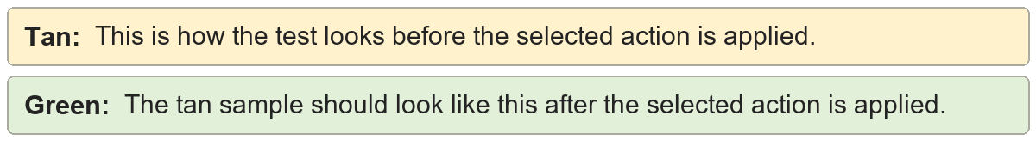
Document properties | Shared metadata sample.
Document properties | Shared metadata sample.

Personal information | Shared metadata sample.
Personal information | Shared metadata sample.

Sharing properties | Shared metadata sample.
Sharing properties | Shared metadata sample.

Author identity | Shared metadata sample.
Author identity | Shared metadata sample.

